Advanced Football Match Outcome Prediction with Machine Learning Techniques

D. A. Olaseinde, Student ID: @00714824
Robotics and Automation, School of Science and Engineering, University of Salford, Manchester M5 4WT, UK
d.a.olaseinde@edu.salford.ac.uk

Abstract The integration of predictive modelling to forecast the outcome of football matches has received substantial interest within the areas of sport analytics and machine learning presenting challenges due to the game’s intrinsic unpredictability. This paper comprises of comprehensive exploration of predictive analysis within the domain of football matches leveraging machine learning models to forecast outcomes. Historical match data, player performance metrics and team dynamics were derived from the “European Soccer Database” available on Kaggle to construct an accurate predictive model. The dataset comprises of 25,000 matches, 10,000 players and 11 European countries ranging from 2008 to 2016.
The methodology also involves the application of machine learning techniques like random forest (RF), support vector machine (SVM) and neural networks and the integration of the ensemble methods like bagging, boosting and stacking methodologies harmonized with a varied array of machine learning algorithms for multiclass classification. The result revealed that while stacking of base models and Neural Networks provided the highest accuracy, simpler models such as Random Forest and Gradient Boosting also performed well, balancing complexity with interpretability.
These implementation aspects were integrated through the utilization of Python, establishing a streamlined and reproducible framework for model development and validation. It also facilitated the practical execution of the theoretical concepts and underscore the significance of methodological rigor and efficiency in predictive modelling. Also, the feature evaluation and model refinement were engaged in an iterative process, highlighting the nature of feature engineering in consistently enhancing the predictive capability of the model, thereby introducing additional features such as the team recent form, which helped with improving the model.

Index Terms - Predictive Modelling, Football Match Forecasting, Machine Learning, Random Forest, Support Vector Machine, Neural Networks, Ensemble Methods, Bagging, Boosting, Stacking, Multiclass Classification, Feature Engineering.

- INTRODUCTION
The advent of machine learning techniques has brought about a paradigm shift in sport analytics thereby revolutionizing the prediction of match outcomes across various sports leagues. In the dynamic and data-rich world of sports, the desire for predictive accuracy in projecting match results has inspired academics and analysts to delve into the depths of machine learning and data science. There is a developing interest in the application of machine learning models to sport analytics to identify patterns and insights from complicated datasets that are not apparent to human observers. Also, the predictive accuracy of these models carries major implications not just for sports betting markets but also for team management and strategy creation. Similarly, persons involved in football betting are exploiting the quantity of football data to anticipate football matches in the hopes of generating profit [1]. The purpose of this paper is to analyse and develop the predictive capabilities of various machine learning models, drawing upon a vast corpus of past work that has provided the framework. This work intends to evaluate the usefulness of ensemble learning techniques such as bagging, boosting and stacking with other machine learning algorithms to estimate football match outcomes accurately. Recent advancements in machine learning and data analytics have opened new avenues for addressing this challenge, with researchers increasingly turning ensemble learning techniques and diverse algorithms to enhance predictive accuracy [2][3].
The work is motivated by the studies of Hu and Fu (2022) [4], who demonstrated the effectiveness of Random Forest, a Gradient Boosting Decision Tree in predicting football match outcomes and by Majumdar et al. (2022) [5] utilizes XGBoost and Gradient Boosting to yield the highest prediction accuracy among various algorithms for the FIFA World Cup. These examples demonstrate the effectiveness of the ensemble approaches in increasing predictive performance, prompting for use in the context of football. The purpose of this project is to construct a prediction model that leverages the strengths of ensemble learning approaches with Random Forest, Support Vector Machine and Neural Network to forecast the outcomes of football matches within the European Football Database gotten from Kaggle. By mixing bagging, boosting, and stacking ensemble methods with algorithms such as Random Forest, SVM, we seek to construct a model that not only outperforms standard single-algorithm approaches but also offers insights into the dynamics that drive match outcomes.
The establishment of the model can be divided into parts, namely Data Collection, Data Pre-processing, Data Splitting, Model training, model testing. The data utilised in this model comprises of 25,000 matches, 10,000 players and 11 European countries ranging from 2008 to 2016 season. The features from this dataset were selected based on their potential impact on the match outcome, reflecting both team-specific characteristics and match-specific conditions. The features used are home team, away team, average player rating, build-up speed, win rate in the last 5 matches, average goals scored in the last 5 matches, average goals conceded in the last 5 matches, league name and some derived and interactive features such as the product of goal count and build-up play speed, rating difference, build-up play speed ratio and recent form index. The data processing was rigorously defined, employing pipelines for efficient data transformation. Numeric attributes were standardized to mitigate issues stemming from disparate scales, while categorical variables underwent one-hot encoding for the input features and label encoding for the output which were derived from the Home and away team goals which produces home team win, away team win and draw. The strategic imputation of missing values further ensured the integrity and robustness of the dataset. After pre-processing using column transformer, 80% of the dataset are utilised as the training set and 20% as the test set for model training. The experimental result reveal that compared with other methods, the Neural Network and Stacking of base models’ method is the best.

A. Literature Review

The emergence of machine learning (ML) and artificial intelligence (AI) has brought about a significant transformation in various industries, including sports analytics. One of the interesting fields of study is the prediction of football match results. This literature review examines the study of past research that concentrated on utilising machine learning algorithms to predict the outcomes of football matches. It emphasizes the progression of predictive modelling in sports, starting from basic statistical models and advancing to more intricate ensemble methods. This review focuses on analysing the range of machine learning (ML) algorithms used, which include traditional classifiers like Support Vector Machines, as well as more advanced ensemble methods like Random Forest classifier, Gradient Boosting, Bagging, Ada Boost, stacking and neural network-based approaches. Emphasis is placed on research that have creatively merged several machine learning techniques to promote stability, address bias and variance in prediction. This evaluation provides a thorough analysis of the criteria utilised for evaluating model performance, the features considered (such as team attributes, player ratings and historical performance) and the level of methodological rigour in each study. It also highlighted the challenges encountered by researchers, such as limited data availability, the need for selecting relevant features and the ever-changing nature of sports that impact the accuracy of models.
Random Forest, an ensemble learning method has been widely adopted for its effectiveness in handling complex datasets with high accuracy. Hu and Fu (2022) [4] utilizes Random Forest alongside other machine learning techniques to analyse data from Premier League and La Liga between 2018 and 2022, with the aim of predicting football match outcomes. The researchers conducted experiments using logistic Regression, Gradient Boosting Decision Trees, and Random Forest algorithms, with a 70% on training data and 30% on testing data. The Random Forest model outperforms other models, reaching an accuracy of 66.7% on the training dataset and 63.8% on the test dataset. The study also leverages match-related features such as goal, shots, fouls, cards to forecast outcomes (Home win, Away win, Draw). The researchers highlighted that the underlying obstacles in accurately predicting football match outcomes is due to the dynamic structure of football teams and the rules of the game. The team line-up is susceptible to regular changes with two transfer windows per season allowing for player transactions which directly alters the team performance and consequently, prediction accuracy. Also, the differences in individual player performances over time diminish the model’s efficacy when older data is being used to predict current matches. [1] also uses Random Forest with other machine learning algorithms like Logistic Regression, Support Vector Machines and Gradient Boosting, to forecast the outcome of football matches in the English Premier League. [1] leveraged datasets enhanced through multiple sampling approaches analysing the efficacy of these models in binary classification tasks, discriminating between home team victories and other outcomes. Random Forest and Logistic Regression emerged as the most proficient models in properly forecasting match results. Choi et al also incorporated the simulation of betting strategies based on the predicted insights given by these models, exploring the potential for profit-making. The challenges faced by these researchers is the lopsided distribution of match outcomes towards home team wins, presenting an imbalance challenge within the dataset that affected the accuracy of the model.
In the extensive study on the Indian Premier League (IPL), Srikantaiah et al. (2021) [6] also utilises the use of machine learning techniques to estimate match results with significant precision. Their research required processing datasets spanning team makeup, match specifics, player performances and in-game statistics across numerous IPL seasons. They utilise the use of algorithms like SVM, Random Forest, Logistic Regression and KNN, they discovered that Random Forest has the highest accuracy reaching 88.1% accuracy in predicting winners. The analysis underlined the significance of elements such as home ground advantage and the outcome of the coin toss, suggesting their major influence on match results. This technique does not only expose the possibilities for predictive analytics in sports but also delivers significant insights for stakeholders such as internet traders and sponsors. The study navigates the variables impacting match outcomes, stressing the problems provided by the dynamic nature of sports, the unpredictability of human performance and external elements such as weather.
Rathan et al. (2018) [7] embarked on an innovative quest to merge social media sentiment research with standard match prediction approaches in their research on forecasting match results. They utilise the Twitter API by methodologically acquiring and cleaning tweets relevant to certain matches, subsequently applying machine learning techniques such as Support Vector Machine and Naïve Bayes to analyse sentiments. The approach is not only tied exclusively to sentiment analysis, but it also includes conventional predictive criteria like team and player form, as well as betting odds. The challenge faced is the intricate process of mining text which requires sophisticated techniques to sift through vast amount of unstructured social media data, identifying and extracting relevant tweets for analysis.
Eryarsoy E and Delen D (2019) [8] embarked on an in-depth investigation of numerous analytical approaches to forecast soccer match results. They focus on a dataset, comprising match outcomes from the Turkish Super League between the years 2007 and 2017. The research employed some number of classifiers, including both single models such as logistic Regression, Decision Trees and Support Vector Machines (SVM), as well as ensemble approaches including Random Forests, Gradient Boosting Machines (GBM), and Adaptive Boosting (AdaBoost). These approaches are evaluated based on their predictive accuracy in identifying whether a game will result in a win, defeat, or draw for the home team. The ensemble methods outperformed the single analytic models in forecasting match outcomes. The Gradient Boosting Machines (GBM) and Random Forest Classifiers exhibit remarkable accuracy, underlying the advantage of leveraging several models’ predictions over depending on a unique predictive framework. They also identify several features influencing match outcomes, including team form, past head-to head results, home advantage and key player injuries. Their research highlights the potential of ensemble approaches in boosting forecast accuracy and provides a basis for further study into more complicated models and datasets.
In the study undertaken by Majumdar et al. (2022) [5], a unique strategy to predicting football match results with machine learning models is rigorously studied. A massive dataset comprising over 43,000 international football matches is being exploited, having undergone exploratory data analysis and precise feature selection techniques. The examination spans a varied array of machine learning models, including Random Forest, Decision Tree, K-Nearest Neighbours (KNN), XGBoost and Gradient Boosting regressors. The models are applied inside a multi-output framework, which ambitiously aims to forecast the scores of both competing teams in a match. Remarkably, leading-edge models like XGBoost and Gradient Boosting stand out for their remarkable performance, exhibiting accuracy rates approaching 98% on the test dataset. Having such high accuracy level underline the potential of modern machine learning approaches in sports forecasts. The research seeks the practical application of these enhanced models to estimate the outcomes of big athletic events, such as the 2022 FIFA World Cup. However, the research also acknowledges the intrinsic unpredictability of football which contributes to its global appeal. Factors like crowd influence, home team advantage, the intimidating environment of away games, underdog victory and dramatic comebacks pose substantial hurdles to predictive modelling.
Ensemble leaning methods, such as bagging, boosting, and stacking, have emerged as a powerful tool in predictive modelling, known for their ability to improve model performance by leveraging the collective strength of multiple learning algorithm [9][3][10] Bagging (Bootstrap Aggregating) increases the stability and accuracy by integrating predictions from multiple models trained on different subsets of the training data [9]. Boosting, sequentially trains models, with each model focusing on correcting the errors of its predecessor, effectively reducing bias and variance in the predictions [3]. Stacking combines the predictions of multiple models, using a meta-learner to output a final prediction, thereby capitalizing on the strength of each of base model.[10].
The use of ensemble method was also conducted by Kozak et al (2021) [11] to forecast the outcomes of football matches in the German Bundesliga league. Their research presents an innovative idea of diverse use of sets of classifiers. Their method entails combining many types of machine learning algorithms to create a stronger and more precise forecasting ensemble. Their research involves a comprehensive dataset that includes match outcomes from the Bundesliga throughout a ten-year period, specifically from 2010 to 2020. The extensive dataset allows the researchers to train their ensemble of classifiers using a wide range of historical data, which includes several factors of the game that impact match results. The primary goal of their ensemble approach is to greatly improve the accuracy of predictions beyond what can be achieved with individual classifiers. They focus on crucial aspects that have historically impacted the outcomes of football matches. These factors entail team rankings, which present a hierarchical view of team performance within the league, past performance statistics, which offer a measurable indication of how many teams have performed in previous matches, and trends over time, which unveil evolving patterns in team performances and league dynamics. Their findings illuminate the road for future studies in sport analytics, calling for the exploration of heterogeneous ensemble models as a promising option for boosting the accuracy and reliability of sports forecast. One of the major issues they contend with is the inconsistent and intrinsically unpredictable nature of sports data. They highlighted that sports data is vulnerable to a myriad of unpredictable factors ranging from player performance variations to elements such as weather. They were also faced with the necessity to precisely capture the chronology and sequence of prior events and consequences. Another challenge is that they found difficulty in discovering and managing relationships between distinct prognostic parameters within their data. The interplay between numerous factors such as team rankings, prior performance statistics, and trends over time, can be exceedingly complex.
Chen (2019) [12] also tackles the area of forecasting the outcomes of football matches based on player ability index data by applying three unique algorithms: Convolutional Neural Network (CNN), Random Forest, Support Vector Machine (SVM). Among these models, the Convolutional Neural Network emerges as the promising, demonstrating an accuracy rate of roughly 57-58% outperforming other algorithms. However, a persistent challenge across all models is the difficulty in reliably predicting draw outcomes, plus a tendency to overestimate victories and underestimate losses. The study shed light on various obstacles encountered in this endeavour including the absence of comprehensive data on influential factors like coach ability and team morale, the inherent difficulty in quantifying subjective variables and imbalance in datasets, particularly regarding draw occurrences. Hassan et al (2020) [13] also embarked on an innovative effort to employ neural network analysis for forecasting the outcomes of matches in the 2018 FIFA World Cup. Utilising the use of radial basis function neural network model, the team methodically accessed data produced from 75 match criteria, collected through a complex system of sensors and cameras. The model was trained with data from 55 matches and was subsequently evaluated on 2 matches, displaying a promising capacity to correctly predict the winner in 83.3% of cases and the loser in 72.7% of cases. They discovered 19 most crucial match attributes determining game results. Attributes that demonstrated the highest sensitivity in forecasting a win encompassed a range of features such as total team medium pass attempts, distance covered within a specific velocity zone (15-20 km/h), team’s efficiency in delivering the ball into attacking third, total distance covered without ball possession, and the average distance covered by the team. However, they encountered some complications in evaluating huge volumes of linear and non-linear data generated from match sensors and cameras, trying to reveal the precise impact of each variable on the match outcome.

B. Paper Outline
The other part of this paperwork is organized and separated into different sections which shows the methodology highlighting the machine learning algorithms used, data preparation, model development and evaluation, results.

II. Methods
- Model Description

The dataset used was gotten from Kaggle provided by Hugo M., encompassing information on numerous football matches, players and teams from several European countries. The data is gathered from several sources, including the reputable football statistics and analysis website, Football-data.co.uk for betting odds and football-data.mx-api.enetscores.com for scores, line-up, team formation and events, sofifa.com for player and team attributes from EA sports FIFA games. It contains data of over 25,000 matches, 10,000 players and 11 European countries from 2008 to 2016 seasons. The downloaded file from Kaggle is SQLite database file. After performing data pre-processing, some features were collected using SQL query and saved into a single .CSV file particularly from the English Premier League.

B. Feature Selection and Feature Engineering

This paper focusses on features that could be known before the start of each match, therefore the following features from this dataset were used: Team attributes, Player attributes, Historical match outcome like the recent. Table 1 shows the features gotten directly from the dataset. To increase the predictive power of the model, some new features were created from the existing data to improve model performance as shown in Table II. The Multiclass output which are the home team goal, and the away team goal were computed into Away Win, Home Win and Draw as shown in Table III. Interactions between the features were also created to increase the performance of the model.
TABLE I
Features that were not created from feature engineering.
No | Features | Data Type | Description
1 | Home Team | Categorical | Identifier for the home team playing the match
2 | Away Team | Categorical | Identifier for the away team playing the match
3 | Home Build Up Play Speed | Numerical | refers to how swiftly the home team passes the ball from defence to attack, essentially determining the speed of their play when transitioning from defending to trying to score
4 | Away Build Up Play Speed | Numerical | refers to how swiftly the away team passes the ball from defence to attack, essentially determining the speed of their play when transitioning from defending to trying to score
5 | Home Defence Aggression | Numerical | refers to how actively the home team tries to regain possession of the ball after losing it.
6 | Away Defence Aggression | Numerical | refers to how actively the away team tries to regain possession of the ball after losing it.
7 | Home Defence Pressure | Numerical | is closely related to defence aggression but focuses more on the intensity and rapidity with which the home team applies pressure on the ball carrier and supporting opponents
8 | Away Defence Pressure | Numerical | is closely related to defence aggression but focuses more on the intensity and rapidity with which the away team applies pressure on the ball carrier and supporting opponents
9 | Output | Categorical | Home Win  Away Win  Draw

TABLE II
features that were created from feature engineering.
No | Features | Data Type | Description
1 | Average Home Player Rating | Numerical | representing the average player ratings for the home team. Useful for capturing the relative strength or form of the teams depending on player performance.
2 | Average Away Player Rating | Numerical | representing the average player ratings for the away team. Useful for capturing the relative strength or form of the teams depending on player performance.
3 | Home Win Rate | Numerical | indicating the win rates of the home teams over their past 5 matches.
4 | Away Win Rate | Numerical | indicating the win rates of the away teams over their past 5 matches.
5 | Home Average Goals Scored | Numerical | indicating the average goals scored by the home teams over their past 5 matches. These measures help understand the offensive capability of the team.
6 | Away Average Goals Scored | Numerical | displaying the average goals scored by the away teams over their past 5 matches. These measures help understand the offensive capability of the team.
7 | Home Average Goals Conceded | Numerical | indicating the average goals conceded by the home teams over their past 5 matches. These indicators are important for measuring the defensive performance of the team.
8 | Away Average Goals Conceded | Numerical | indicating the average goals conceded by the away teams over their past 5 matches. These indicators are important for measuring the defensive performance of the teams.
9 | Home Goal Count * Build-up Play Speed | Numerical | represent an interaction between the number of goals and the team's build-up play speed in home team.
10 | Away Goal Count * Build-up Play Speed | Numerical | represent an interaction between the number of goals and the team's build-up play speed in away team.
11 | Build-up Play Speed Ratio | Numerical | Ratio of the home team’s build up play speed to that of the away team’s build up play speed.

Feature selection is used to remove redundant and irrelevant data that can reduce the accuracy of the model, increasing training time and sometimes leading to overfitting. Feature importance derived from trained Random Forest was used to perform feature selection. This step eliminated 9 features out of the 19 features leaving 10 features. Recursive feature elimination (RFE) was also used when SVM was fitted. RFE remove the weakest features using SVM coefficients, iterating the process until the desired number of features is achieved.

TABLE III
target variable distribution in the dataset
Match outcome | Number of Records
Home Win | 1390
Away Win | 867
Draw | 783
Total | 3040

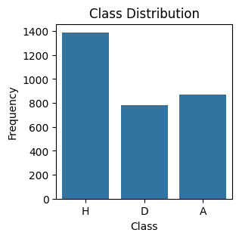
Figure 1. Chart of the target distribution.

C. Machine Learning Algorithm

Random Forest, SVM, Neural Network and ensemble methods were the machine learning used for training the multiclass model.
1. Random Forest
Random Forest is an ensemble method well suited for multiclass classification problems, where goal is to assign an instance into one of three or more classes based on its features. It builds multiple decision trees during training and outputs the class that is the mode of the classes (classification) of the individual trees. For multiclass problems, it means that each tree gets to vote on the class, and the class with the most votes is chosen as the final prediction [1]. It does not require one-vs-all (OvA) or one-vs-one (OvO) strategies commonly used by algorithms that are inherently binary classifiers. During the construction of the trees, Random Forest randomly selects a subset of features at each split which contributes to the diversity among the trees and is beneficial for high-dimensional data, making the algorithm robust to overfitting and capable of handling irrelevant features.
2. Support Vector Machine
Support Vector Machine (SVM) is also known as Support Vector Networks, which uses learning algorithms to analyse data for classification and regression analysis. SVMs are designed to find the maximum margin between different classes in the data, making them effective for separating and categorising data points. Strategies like One-vs-All (OvA) and One-vs-One (OvO) is used for multiclass classification. For an N-class problem in One-vs-All (OvA), N separate classifiers are trained. Each one separates one class from all the rest. For an unknown sample, the classifier with the highest output function assigns the class. For an N-class problem in One-vs-One (OvO), N * (N-1)/2 classifiers are trained, each one separating a pair of classes. The class that wins the most is assigned to the sample. One-vs-One tends to be more computationally expensive than One-vs-All but can be more accurate, especially in cases where the number of instances of each is unbalanced.
3. Neural Network
It is also known as artificial neural networks (ANNs). It is a computational models inspired by the structure and functioning of the human brain [14]. It is composed of interconnected nodes, called neurons, organized in layers. The input layer receives the input data and passes it on to the next layer. Each neuron in the input layer represents one feature of the input data. The hidden layer is between the input and output layers and perform complex transformations on the input data. Each neuron in the hidden layer takes inputs from the previous layer whether hidden or input layer, applies a weighted sum, add a bias, and passes the result through an activation function. The output layer produces the final output of the network. The number of neurons in the input layer depends on the type of problem being solved. In multiclass classification, there may be multiple neurons, each representing the probability of one class using SoftMax as the activation function. Each connection between neurons in adjacent layers has associated weights and biases. These parameters are learned during the training process and determine the strength of the connections and the neuron’s activation threshold, respectively. The activation functions introduce non-linearity into the neural network, allowing it to learn complex patterns in the data. Common activation functions include sigmoid, tanh, ReLU, and SoftMax. The loss function measures the difference between the predicted output of the network and the true output which aims to minimize during training. The optimisation algorithm updates the weights and biases of the network to minimize the loss function.
4. Bagging
Bagging is an ensemble learning technique that combines multiple models to improve predictive performance. It uses a collection of base learners such as decision trees or another algorithm, as its base model. Each base learner is trained independently on a subset of the training data. It employs bootstrap sampling to create multiple subsets of the training data. In bootstrap sampling, random samples of the same size as the original dataset are drawn with replacement. After the base learners are being trained, their predictions are combined or aggregated to make the final prediction. For classification tasks, a common aggregation method is a majority or weighted majority voting. It can be parallelized, allowing base learners to be trained concurrently. Bagging reduces variance by averaging the predictions of multiple base learners, resulting in a more robust model. It also helps to prevent overfitting and improves the model’s ability to generalise to unseen data. Bagging leverages
5. Boosting
Boosting is an ensemble learning technique used to improve the performance of machine learning models by sequentially combining multiple weak learners to create a strong learner. Contrary to bagging which trains each model independently and combines them to make predictions, boosting focuses on training models sequentially, where each model tries to correct the errors made by the previous ones. In boosting, weak learners are typically simple models that perform slightly better than random guessing. Each new model in boosting is trained on data that emphasizes the instances that previous models misclassified. It is usually achieved by adjusting the weights of training instances based on the previous model’s accuracy, making the subsequent model focus more on the difficult cases. Each model attempts to correct the errors of its predecessors. The final prediction is made based on a weighted combination of all the models’ predictions, where weights depend on each model’s accuracy. It also includes a mechanism to prevent overfitting. It includes parameters to control the number of iterations or depth of the decision tree used a weak learner. There are several boosting algorithms which are AdaBoost (Adaptive Boosting), Gradient Boosting, XGBoost (Extreme Gradient Boosting), LightGBM (Light Gradient Boosting Machine) and CatBoost (Categorical Boosting). AdaBoost focuses on instances that previous models misclassified by adjusting their weights. It combines multiple weak learners into strong learner by giving more weight to models to perform better. The AdaBoost algorithm is an iterative process that aims to approximate the Bayes classifier C*(x) by aggregating many weak classifiers [15]. Gradient Boosting is a modelling technique that constructs models in a step-by-step manner, like AdaBoost. Its advantage is that it optimises any differentiable loss functions, which provides more flexibility and improving the performance of the models. XGBoost (Extreme Gradient Boosting) is a very efficient and scalable implementation of gradient boosting. Its advantage is its exceptional efficiency and speed. LightGBM (Light Gradient Boosting Machine) is a tool that enhances the performance and speed of standard gradient boosting methods. It achieves this by incorporating parallel and GPU learning capabilities. It exhibits high efficacy when applied on extensive datasets. CatBoost (Categorical Boosting) is specifically designed to automatically and efficiently handle categorical variables, hence minimising the requirement for substantial data pre-processing. It exhibits resilience against overfitting and demonstrates efficacy across diverse datasets.
6. Stacking
Stacking is an ensemble learning strategy that integrates multiple classification or regression model via meta-classifier or a meta-regressor. The base learning models are trained based on the whole training set, then the meta-model is trained on the outputs of the base learning model as features. This strategy is done to obtain superior prediction performance relative to any one model in the ensemble. The training set is separated into two subgroups having the first subset utilised to train the base models. Several models are trained independently on the initial subset. The base models generate predictions on the second subset. These predictions are utilised as features to train a higher-level model, the meta-model. The meta-model learns how to best combine the predictions of the base models to generate a final prediction. The base models used was Random Forest, SVM and Decision tree classifier. The meta-model combines the predictions from the base models. Logistic regression was used for the multiclass classification.

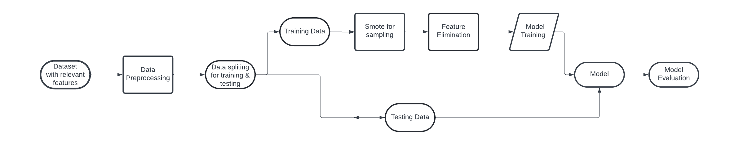
Figure 2. Overall process of the model training.

Overview of the model training and evaluation process
The workflow involves retrieving relevant features from the dataset, pre-processing, data balancing with SMOTE, feature selection, hyperparameter tuning using GridSearchCV and RandomisedSearchCV, and evaluation of the model as shown in Figure 2. The model evaluation involves assessing the performance of the machine learning model on the data separated from the data on which the model was trained. It helps to estimate how well the model will perform on unseen data. Here are the metrics used for model evaluation:
1. Accuracy: It is the ratio of correctly predicted instances to the total instances. It is the ratio of number of correct predictions to the total number of input samples.
2. Precision: It is the ration of the correctly predicted positive instances to the total predicted positives, it measures the quality of the positive predictions
3. Recall: It is the ratio of correctly predicted positive instances to all the instances in actual class. It measures how well the model captures the positive cases.
4. F1 score: It is the weighted average of precision and recall. It takes both false positives and false negatives.
5. Confusion Matrix: It is a table showing the model predictions against the actual classification. It also provides insights into the types of error made by the model.

D. Data Preparation

Pre-processing was done for transforming raw data into understandable format to enhance the quality and efficacy of data modelling. The data missing values and models require complete data for accurate computation. The numerical data contains missing values which was imputed using statistical method (median). Standardscaler was also used to standardise features by removing the mean and scaling to unit variance. It is important for models that are sensitive to the scale of the input data like SVMs and neural networks. The numerical data type was also converted to float32. This is done to reduce memory consumption, especially working with models that do not require high precision. For categorical data, missing values was replaced with the string ‘missing’. This ensure that all data points can be used in the subsequent steps without dropping any due to missing values. The categorical data was also transformed into binary matrix representation that is suitable for modelling using the OneHotEncoder. Also, the output was also cast to ‘float32’. The ColumnTransformer combines the separate pipelines for numerical and categorical data. It also allows different columns of the input data frame to be processed using different pipelines in parallel, which is efficient and convenient for handling datasets with heterogeneous data types.

E. Strategy for dataset splitting.

The dataset was split into training and testing subsets to ensure that the model is thoroughly trained and tested to evaluate its performance under unbiased conditions. The dataset was split into 80% training and 20% testing. The testing data was also used as the validation data which was validated to tune hyperparameters without overfitting.

F. Model Development

A range of machine learning algorithms like SVMs, Neural Networks, Random Forest, and combining with ensemble methods like bagging, boosting and stacking was used to develop a predictive model to forecast outcomes of football matches in the English Premier League from the European Football Database.
A parameter grid was defined to specify the different configurations over which the grid search will be performed. The GridSearchCV was configured with a 5-fold cross validation strategy, focusing on maximising accuracy. It comprehensively searches through the defined grid of parameters, fitting the pipeline that combines the processing, the Synthetic Minority Over-sampling Technique (SMOTE) and the RandomForestClassifier on various subset of the data. The SMOTE is used to oversample the minority class in the dataset to handle class imbalance issues. Then after training, the best parameter set was identified, providing insights into the optimal model configuration. The highest obtained cross-validation score was also reported indicating the model’s effectiveness on unseen data during training. Feature importance scores were extracted from the model. As shown in Figure 3, The features were sorted by their importance, highlighting the most influential features in making predictions.

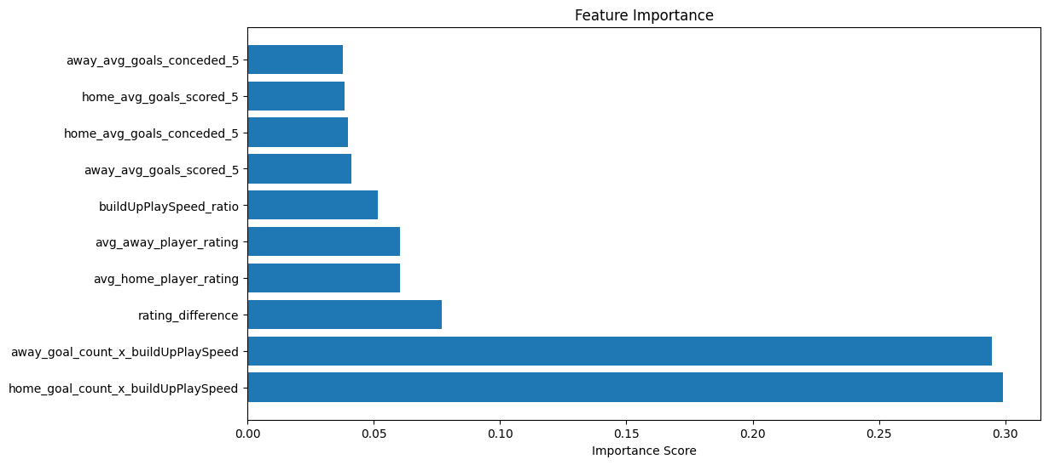
Figure 3. Features gotten from feature selection.

The GridSearchCV approach facilitated an efficient exploration of the model, identifying the optimal combination of parameters and features.
SVM model pipeline was configured with a pre-processing which involves the standardisation of numerical features and one-hot encoding of categorical features, Recursive Feature Elimination with an SVM estimator to select the most impactful features, SMOTE which was applied to address the class imbalance, aiming to improve minority class prediction and the SVM classifier which was configured with a linear kernel and regularisation parameter. The model was trained using the pipeline on the training data. The selected features from RFE were identified to understand their impact on the model. 5-fold StratifiedKFold cross-validation was used to ensure balanced sampling of classes across folds. The training data was used to find the optimal combination of parameters and features defined. The selection of key features through RFE and the optimisation of the SVM’s regularisation strength tailored the model to effectively handle the dataset’s characteristics and class imbalances.
Bagging Classifier was also used to improve the predictive performance on a potentially imbalanced dataset by incorporating ensemble methods, feature selection and Synthetic Minority Over-sampling Technique (SMOTE). A pipeline was configured with pre-processing, Recursive Feature Elimination (RFE) with a base estimator of Random Forest which was employed to select the top 10 features, focusing the model on the most relevant attributes, SMOTE which enhances the model’s ability to generalise to minority classes and the Bagging Classifier using a Random Forest with specific parameters nested as the base estimator. The model employed Grid Search CV with a stratifiedKFold strategy to optimise hyperparameters specific to the Bagging Classifier’s depth and the number of estimators, then the model was trained on the training dataset to find the optimal combination of parameters.
Another pipeline with the same process of data pre-processing, feature selection, class imbalance correction and classification using Gradient Boosting was defined. The numerical features undergo median imputation and conversion to float32 datatype to ensure compatibility and potentially reduce memory usage. The Categorical features are filled with the value ‘missing’ for any missing data and the one-hot encoded to convert categorical data into a format that can be provided to machine learning algorithms. Feature selection is performed using Recursive Feature Elimination (RFE) with a Random Forest Classifier as the estimator and it was configured to select the top 10 features, which could help improve model performance by reducing overfitting and improving generalisation. To address the issue of class imbalance, SMOTE is used to oversample the minority class in the training data. Then a Gradient Boosting was also included as the machine learning algorithm which builds models sequentially, each model correcting errors made by the previous models.
A pipeline which integrates pre-processing, feature selection, class imbalance correction, and a bagging ensemble of SVM classifier to address a classification. At the pre-processing stage, the numerical features are processed through median imputation, standard scaling and conversion to ‘float32’ for optimal performance and compatibility. The categorical features are handled by filling missing values with ‘missing’ and converting the data into format that can be used by the machine learning model through one-hot encoding. Feature selection is achieved using Recursive Feature Elimination with an SVM classifier configured with a linear kernel. This technique aims to identify the most impactful features by iteratively considering smaller sets of features based on their importance and it was to select top 10 features, which can help in reducing the complexity of the model and improving its performance. SMOTE was also used to tackle potential issues arising from class imbalance, thereby balancing the class distribution in the training dataset. Then the classifier which is the ensemble of Support Vector Machine (SVM) classifiers using Bagging. Bagging trains multiple versions of a predictor on different random subsets of the training set and then averaging their predictions to improve generalisation and control overfitting.
The development, configuration and optimisation of a machine learning pipeline integrating an AdaBoost ensemble with an SVM classifier, focused on a classification problem with an imbalanced class. A pipeline which encompasses pre-processing which standardise and encode the input features to ensure they are suitably formatted for machine learning models, utilising median imputation and standard scaling for numerical features and one-hot encoding for categorical features. The pipeline also contains feature selection performed using RFE with a linear kernel SVM which helps to improve model efficiency and effectiveness by reducing the dimensionality. SMOTE was also included in the pipeline which addresses the class imbalances. The AdaBoost Classifier is set to use the SVM classifier with the SAMME algorithm. It adapts to the idiosyncrasies of the data by adjusting the weights of incorrectly classified instances which aims to improve the performance of the SVM by focusing learning on the harder cases in sequential model training. The Grid Search optimisation technique is employed to find the best parameters for feature selection and the AdaBoost configuration. It evaluates the combination of the RFE-selected features and AdaBoost settings utilising cross-validation for robustness. Then the cross validation was utilised with 5 splits to ensure each fold is a good representative of the whole dataset.
Also, stacking ensemble model was developed and optimised for a classification problem with imbalanced classes. This model employs a combination of diverse base learners and logistic regression model as the final estimator to make the final prediction. It combines the strengths of individual learners to achieve higher accuracy. A pipeline was defined which encompasses the pre-processing that ensures all input features are suitably transformed for use in machine learning models. SMOTE was also applied to augment the minority class through synthetic examples, enhancing the model’s ability to generalise across both classes. The stacking classifier integrates multiple base learners with a final logistic regression model. The base learners are SVC with probability estimates enabled, Random Forest and Decision Tree. The final estimator is the logistic regression used to combine the predictions from the base learners. The GridSearchCV was utilised to optimise over a defined parameter, and the 5-fold cross-validation during grid search which helps in validating the model’s effectiveness and prevents overfitting by ensuring the model is trained and validated on different subsets of the data.
A neural network model was designed to classify instances into one of three categories. This model employs a deep learning framework implemented using TensorFlow and Keras and is constructed to handle multi-class classification problems by leveraging a SoftMax output layer. The target variables which was integer labels ranging from 0 to 2 (using label encoder) were converted to a one-hot encoded format using Keras’ ‘to_categorical’ function, expanding each label into a binary vector of length three, which is essential for multi-class classification using SoftMax. The input features were scaled and transformed using a pre-processing pipeline that normalised and encoded various feature types to make them suitable for model input. The input layer is configured to accept the features derived directly from the pre-processed data. The hidden layers include a sequence of dense layers with rectified linear activation. L2 regularisation was also used to mitigate overfitting by penalising large weights. The output layer comprises three neurons corresponding to the three categories, utilising SoftMax activation to output a probability distribution over the three classes. The Adam optimiser was chosen for its efficiency in handling sparse gradients and adaptive learning rate capabilities. Categorical cross entropy is used for multi-class classification problems where each target class label is provided in a one-hot encoded format.

III. Results
Figures 4, 5, 6, 7, 8, 9 and 10 show the comparison of accuracy, macro precision, macro recall, macro F1-score, weighted precision, weighted recall, weighted F1-score for all the models trained on multiclass classification. Among the various models evaluated, the Neural Network and Stacking of Random Forest, SVM and Decision Tree classifiers stand out as the best performing model. Each of these models achieved an accuracy of 88%, along with high scores in precision, recall, and F1-score both macro and weighted averages.
The neural network model shows a high accuracy and a balanced precision and recall, indicating a good balance between Type I (False Positive) and Type II (False Negative) errors. The Type I error is an error that occurs when the model predicts a positive outcome when it is not true. Type II error is an error that occurs when the model fails to detect a positive outcome when it is present.
The stacking classifier integrates predictions from Random Forest, SVM and Decision Tree classifiers models and uses a logistic regression model as the final estimator. This strategy of leveraging diverse base learners and a meta-learner for final predictions seems to provide robust performance, as seen by its consistent precision, recall, F1 scores.
Both the Neural Network and Stacking Classifiers not only achieved high accuracy but also maintained high precision and recall. This indicates fewer false positives and false negatives, making these models reliable for practical applications where both types of errors are costly. The sophisticated architectures of the Neural Network and Stacking models suggest that the complexity introduced by multiple layers and combination of different types of models can be used to attain higher performance in multiclass classification task. The AdaBoost with SVM as its estimator has lower performance across all metrics, which might be the inherent limitations of AdaBoost in adapting to SVM’s output. The ensembles methods like Random Forest, Bagging and Gradient Boosting performed better than single instance models like SVM. It indicates the effectiveness of ensemble techniques in improving prediction accuracy and model robustness by reducing variance and bias.

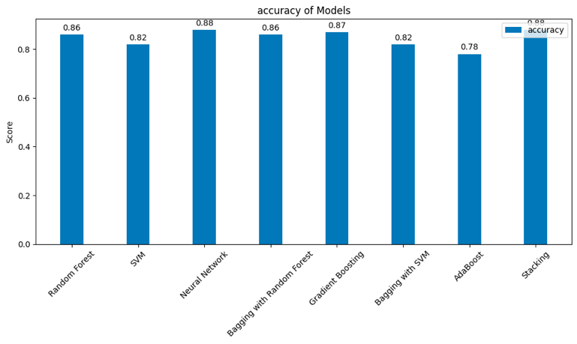

Figure 4. Accuracy of Models.

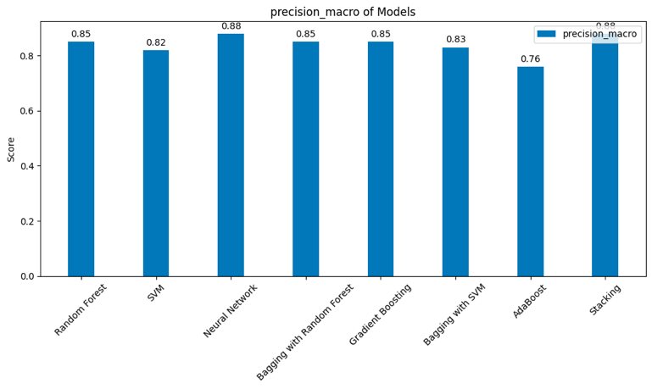

Figure 5. Macro precision of the models.

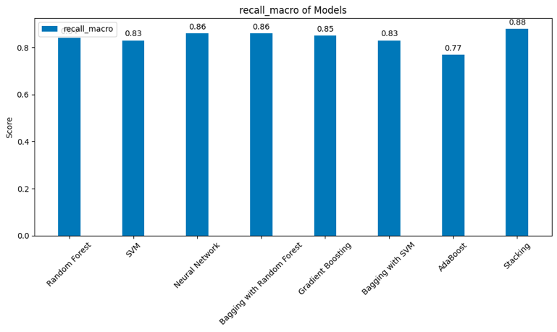

Figure 6. Macro recall of the models.
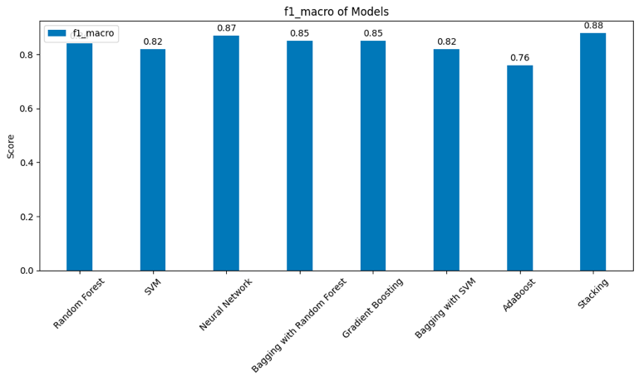

Figure 7. Macro F1 score of the models.

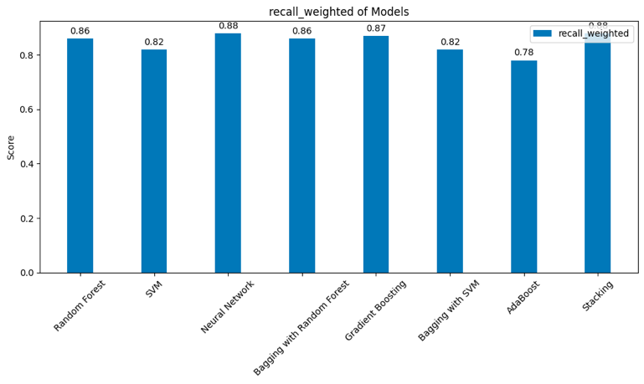

Figure 8. Weighted recall of the models.

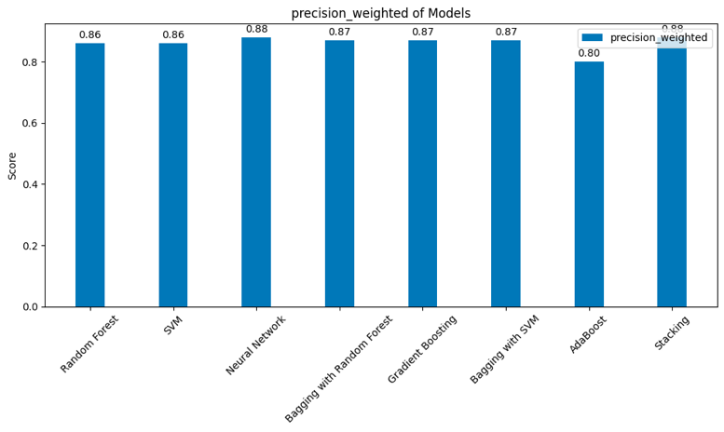

Figure 9. Weighted precision of the models.
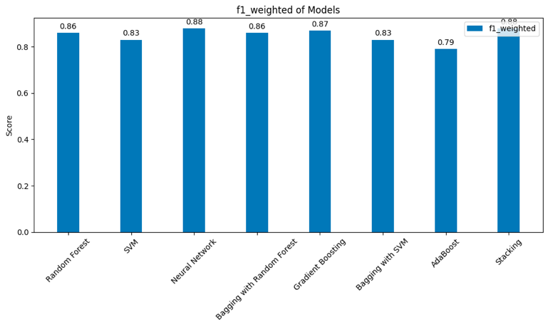

Figure 10. Weighted F1 score of the models.

IV. Conclusions
This project demonstrated the use of machine learning techniques to predict football match outcomes based on team attributes, average player ratings, historical win rates, and goal statistics from recent matches. Among the models tested, the Stacking classifier and the Neural Network were the most effective, achieving high accuracy and robustness in prediction. Simpler models like Random Forest and Gradient Boosting also performed better, suggesting a trade-off between model complexity and interpretability. Future work could explore getting more data sources such as player-level data, match conditions to enhance the predictive power of the models. However, while this predictive modelling presents a power tool for forecasting football match outcomes, it requires careful implementation, continuous refinement and a balanced consideration of risk and reward to support decision making in the dynamic field of sports.

Acknowledgments
First and foremost, special thanks to the module lecturers in the person of Prof. Mary He. And Dr Saleem Ameen for their dedication and hard work in the workshop and during lectures. Also, thank the University of Salford for providing us with a wonderful living lab for the experiment.

References
[1] B. S. Choi, L. K. Foo, and S.-L. Chua, “Predicting Football Match Outcomes with Machine Learning Approaches,” MENDEL, vol. 29, no. 2, pp. 229–236, Dec. 2023, doi: 10.13164/mendel.2023.2.229.

[2] S. Pant, Y. H. Lee, and R. Smith, “Machine learning in sports betting. Journal of Prediction Markets,” vol. 15, no. 1, pp. 77-89., 2021.

[3] Y. Freund and R. E. Schapire, “A Decision-Theoretic Generalization of On-Line Learning and an Application to Boosting,” J Comput Syst Sci, vol. 55, no. 1, pp. 119–139, Aug. 1997, doi: 10.1006/jcss.1997.1504.

[4] S. Hu and M. Fu, “Football Match Results Predicting by Machine Learning Techniques,” in 2022 International Conference on Data Analytics, Computing and Artificial Intelligence (ICDACAI), IEEE, Aug. 2022, pp. 72–76. doi: 10.1109/ICDACAI57211.2022.00022.

[5] A. Majumdar, R. Kaur, T. Kulkarni, M. Jiruwala, S. Shah, and N. Pise, “Football Match Prediction using Exploratory Data Analysis &amp; Multi-Output Regression,” in 2022 IEEE Conference on Interdisciplinary Approaches in Technology and Management for Social Innovation (IATMSI), IEEE, Dec. 2022, pp. 1–6. doi: 10.1109/IATMSI56455.2022.10119340.

[6] K. C. Srikantaiah, A. Khetan, B. Kumar, D. Tolani, and H. Patel, “Prediction of IPL Match Outcome Using Machine Learning Techniques,” 2021. doi: 10.2991/ahis.k.210913.049.

[7] Rathan M, Deepthi Raj N, Anupriya S, and Sanketh and Vishnu V, “FOOTBALL MATCH OUTCOME PREDICTION USING SENTIMENT ANALYSIS OF TWITTER DATA,” International Journal of Advanced Research in Computer Science, vol. 9, no. 3, 2018.

[8] E. Eryarsoy and D. Delen, “Predicting the Outcome of a Football Game: A Comparative Analysis of Single and Ensemble Analytics Methods,” 2019. doi: 10.24251/HICSS.2019.136.

[9] L. Breiman, “Bagging predictors,” Mach Learn, vol. 24, no. 2, pp. 123–140, Aug. 1996, doi: 10.1007/BF00058655.

[10] D. H. Wolpert, “Stacked generalization,” Neural Networks, vol. 5, no. 2, pp. 241–259, Jan. 1992, doi: 10.1016/S0893-6080(05)80023-1.

[11] J. Kozak and S. Głowania, “Heterogeneous ensembles of classifiers in predicting Bundesliga football results,” Procedia Comput Sci, vol. 192, pp. 1573–1582, 2021, doi: 10.1016/j.procs.2021.08.161.

[12] H. Chen, “Neural Network Algorithm in Predicting Football Match Outcome Based on Player Ability Index,” Advances in Physical Education, vol. 09, no. 04, pp. 215–222, 2019, doi: 10.4236/ape.2019.94015.

[13] A. Hassan, A.-R. Akl, I. Hassan, and C. Sunderland, “Predicting Wins, Losses and Attributes’ Sensitivities in the Soccer World Cup 2018 Using Neural Network Analysis,” Sensors, vol. 20, no. 11, p. 3213, Jun. 2020, doi: 10.3390/s20113213.

[14] A.D.Dongare, R.R.Kharde, and Amit D.Kachare, “Introduction to Artificial Neural Network,” International Journal of Engineering and Innovative Technology (IJEIT), vol. 2, no. 1, Jul. 2012.

[15] T. Hastie, S. Rosset, J. Zhu, and H. Zou, “Multi-class AdaBoost,” Stat Interface, vol. 2, no. 3, pp. 349–360, 2009, doi: 10.4310/SII. 2009.v2.n3.a8.

